# Jenkins To Jira Integration

## 1.jenkins setup

* Install Jira plugins

Manage Jenkins -> Manage plugins -> install plugins

* Jira
* Jira trigger configuration
* Jira issue updater

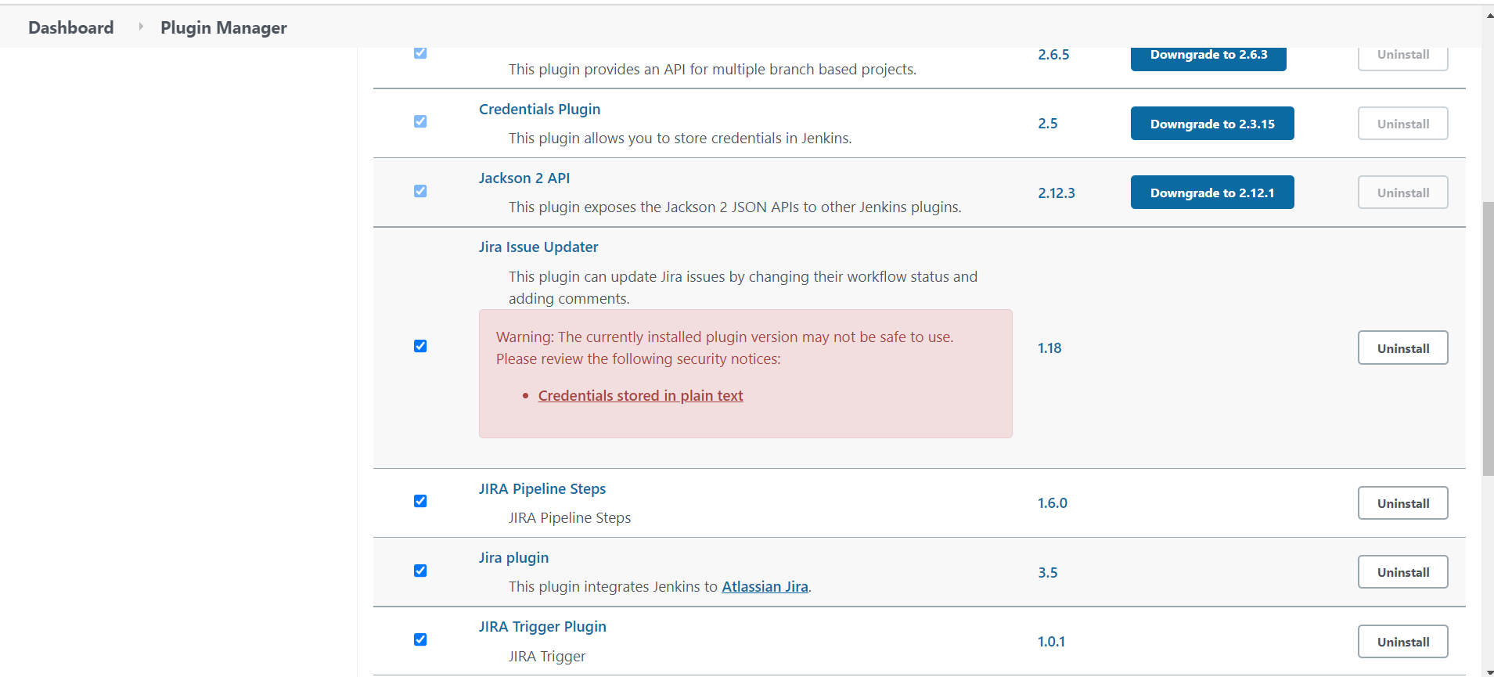

* After Installation Env setup go to Manage Jenkins -> configure-> jira steps

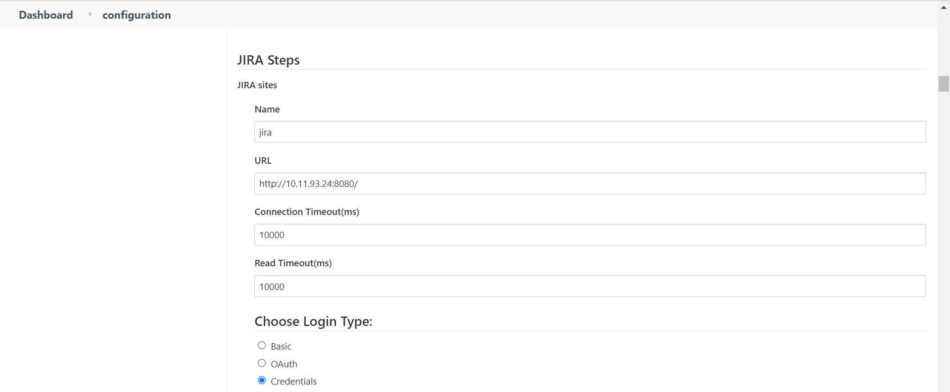

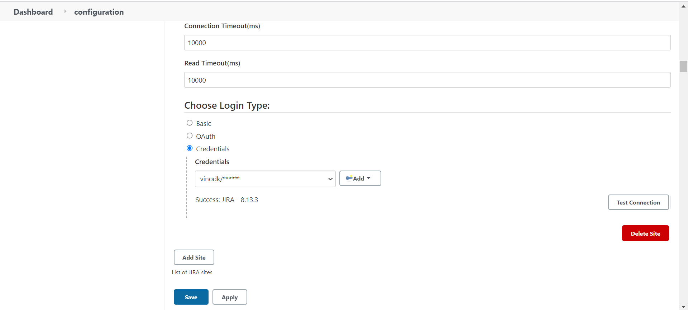

* Manage Jenkins->Configure system -> Env setup in Jira triggers path

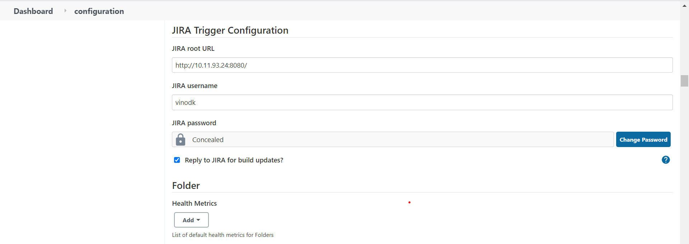

* Manage Jenkins->Configure system-> jira Env setup

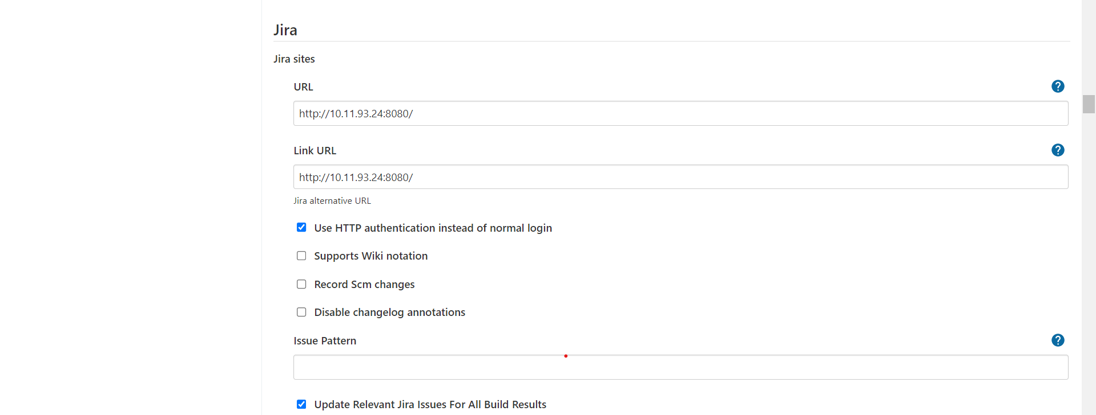

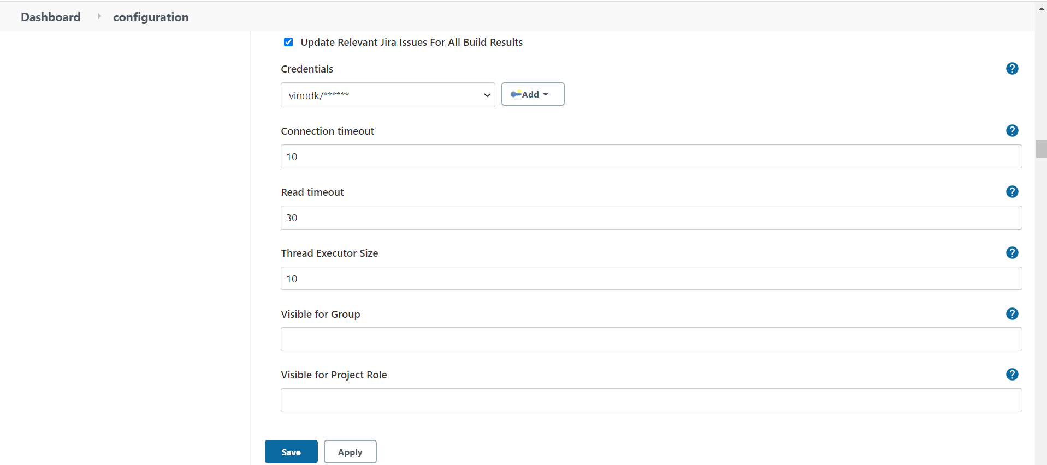

## 2 . project setup In Jenkins

* New item -> Choose Freestyle project
* Configure project

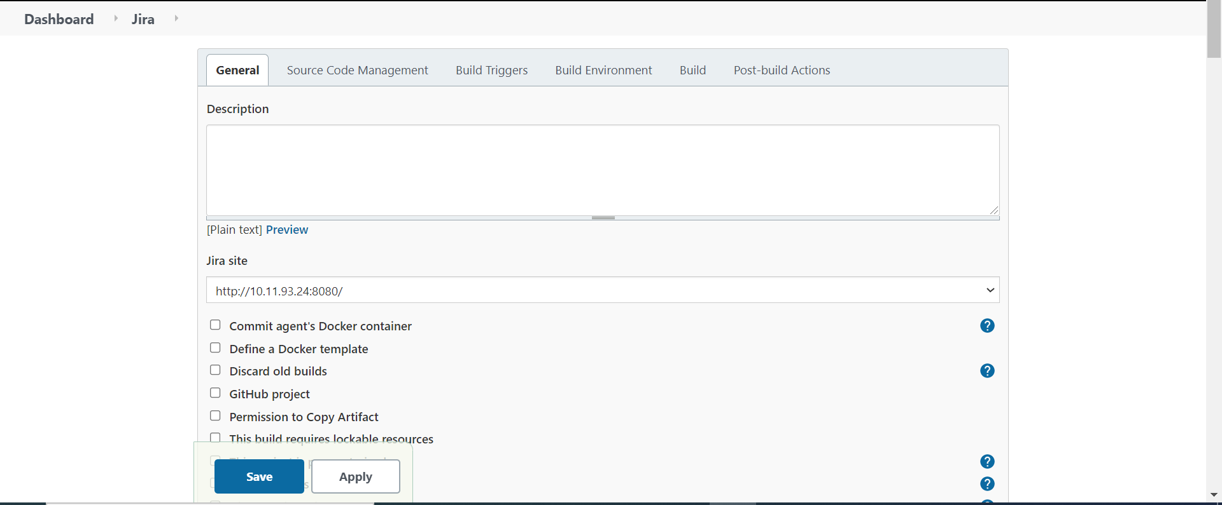

* Build Triggers choose a option
* Build when an issue is updated in JIRA

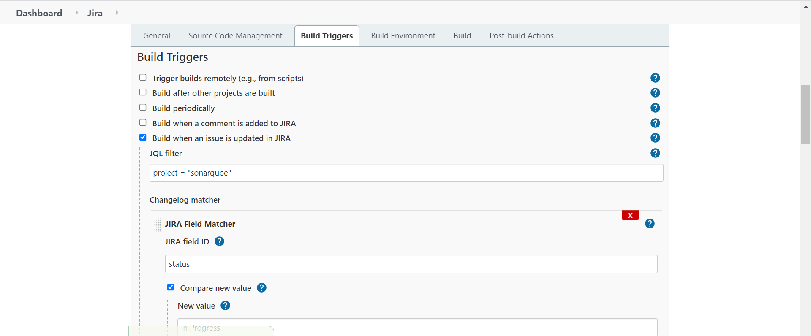

* Choose Build option Excute shell

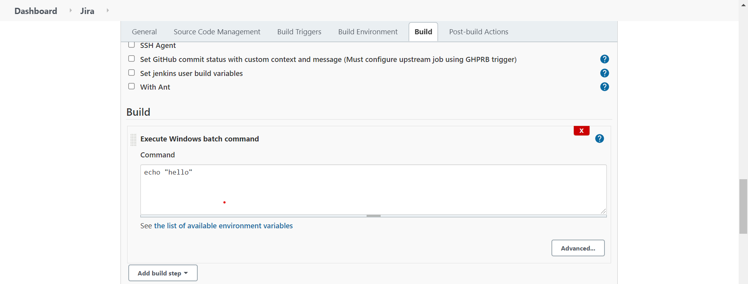

* Choose Post build actions
* Choose jira update relevant issue

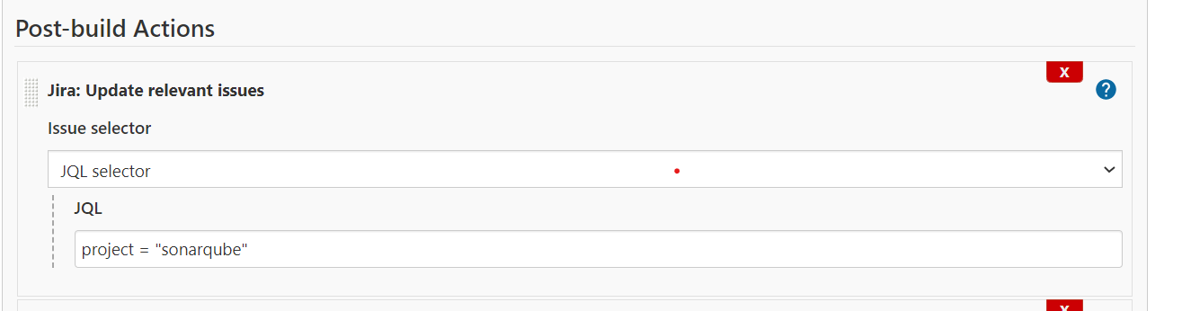

* Choose jira create issue

Project key = SON (In jira project ID)

Issue Priority=[http://10.11.93.24:8080/]Medium (choose option depends upon priority)

Issue Type=[http://10.11.93.24:8080/]Task (choose option depends upon Type)

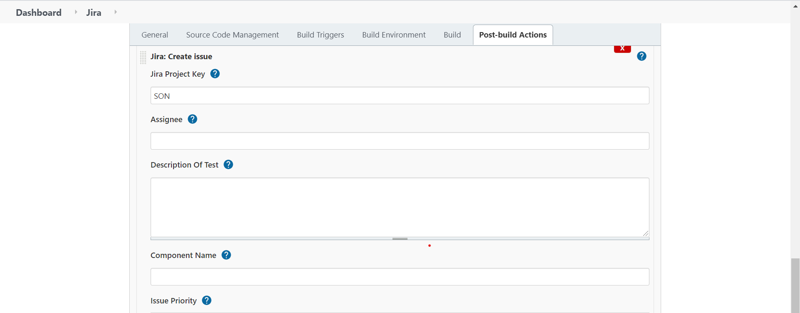

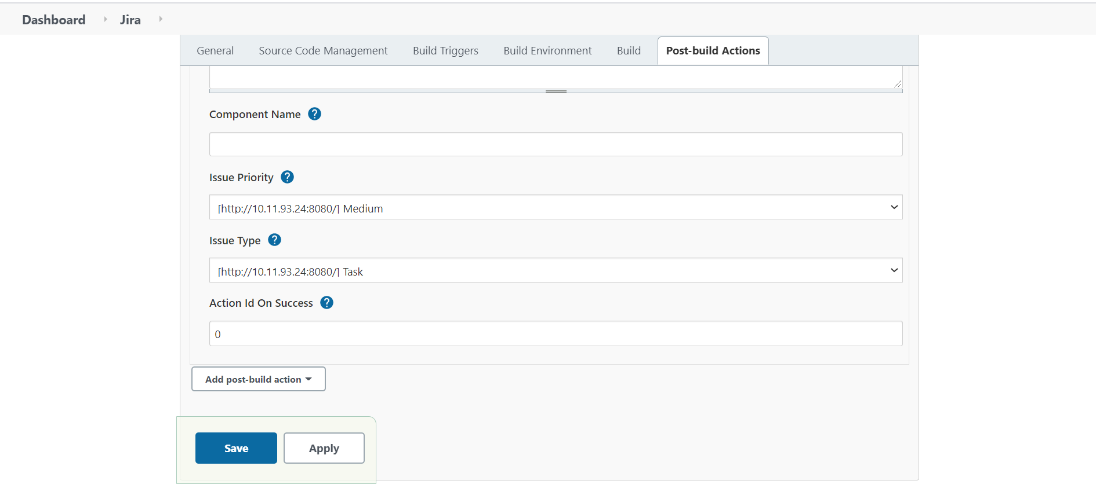

### 3 .Jira server setup

* Admin access required
* After Login choose system option

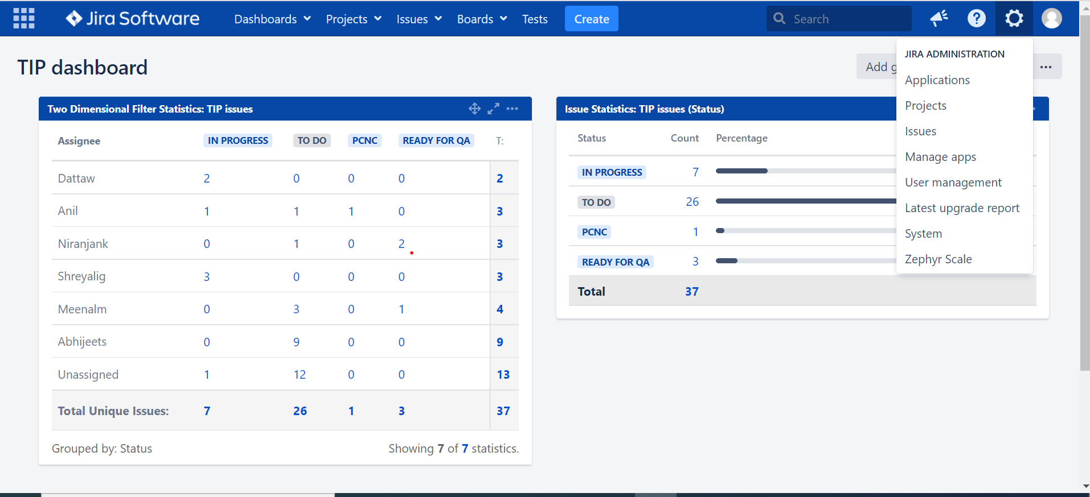

* Inside System Administration setup in webhooks

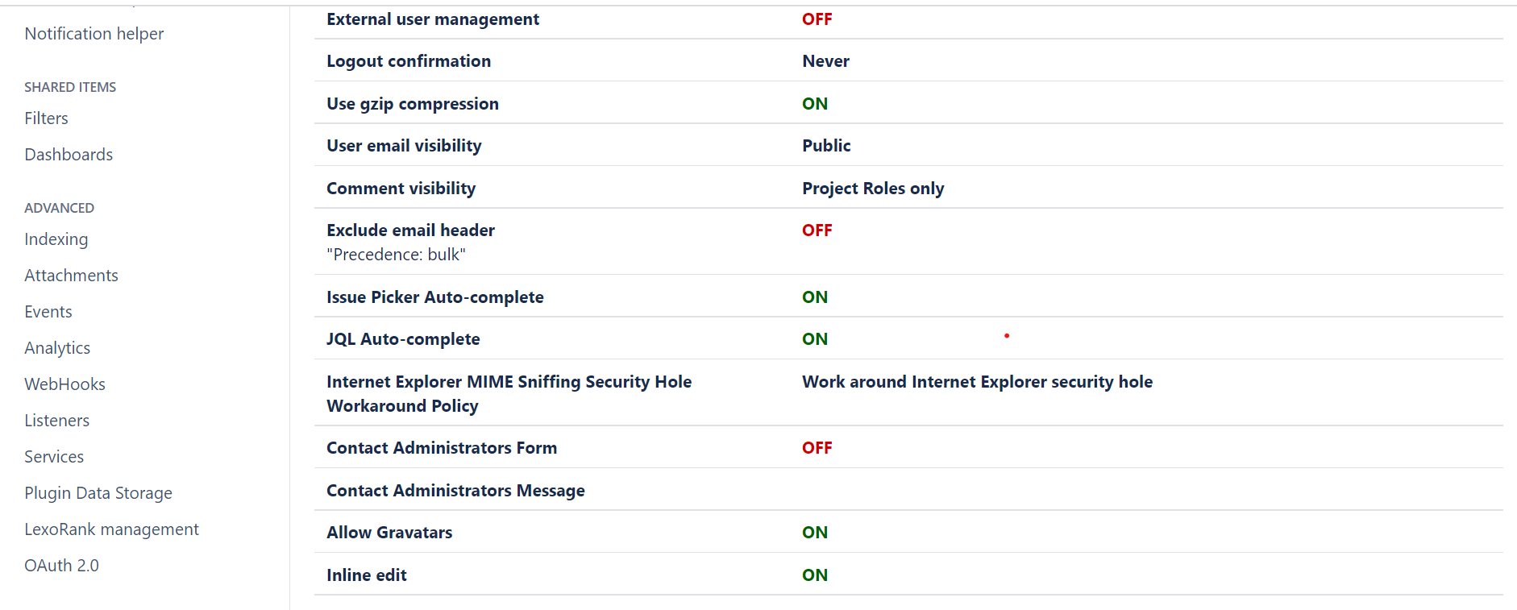

* Open webhooks and create webhooks

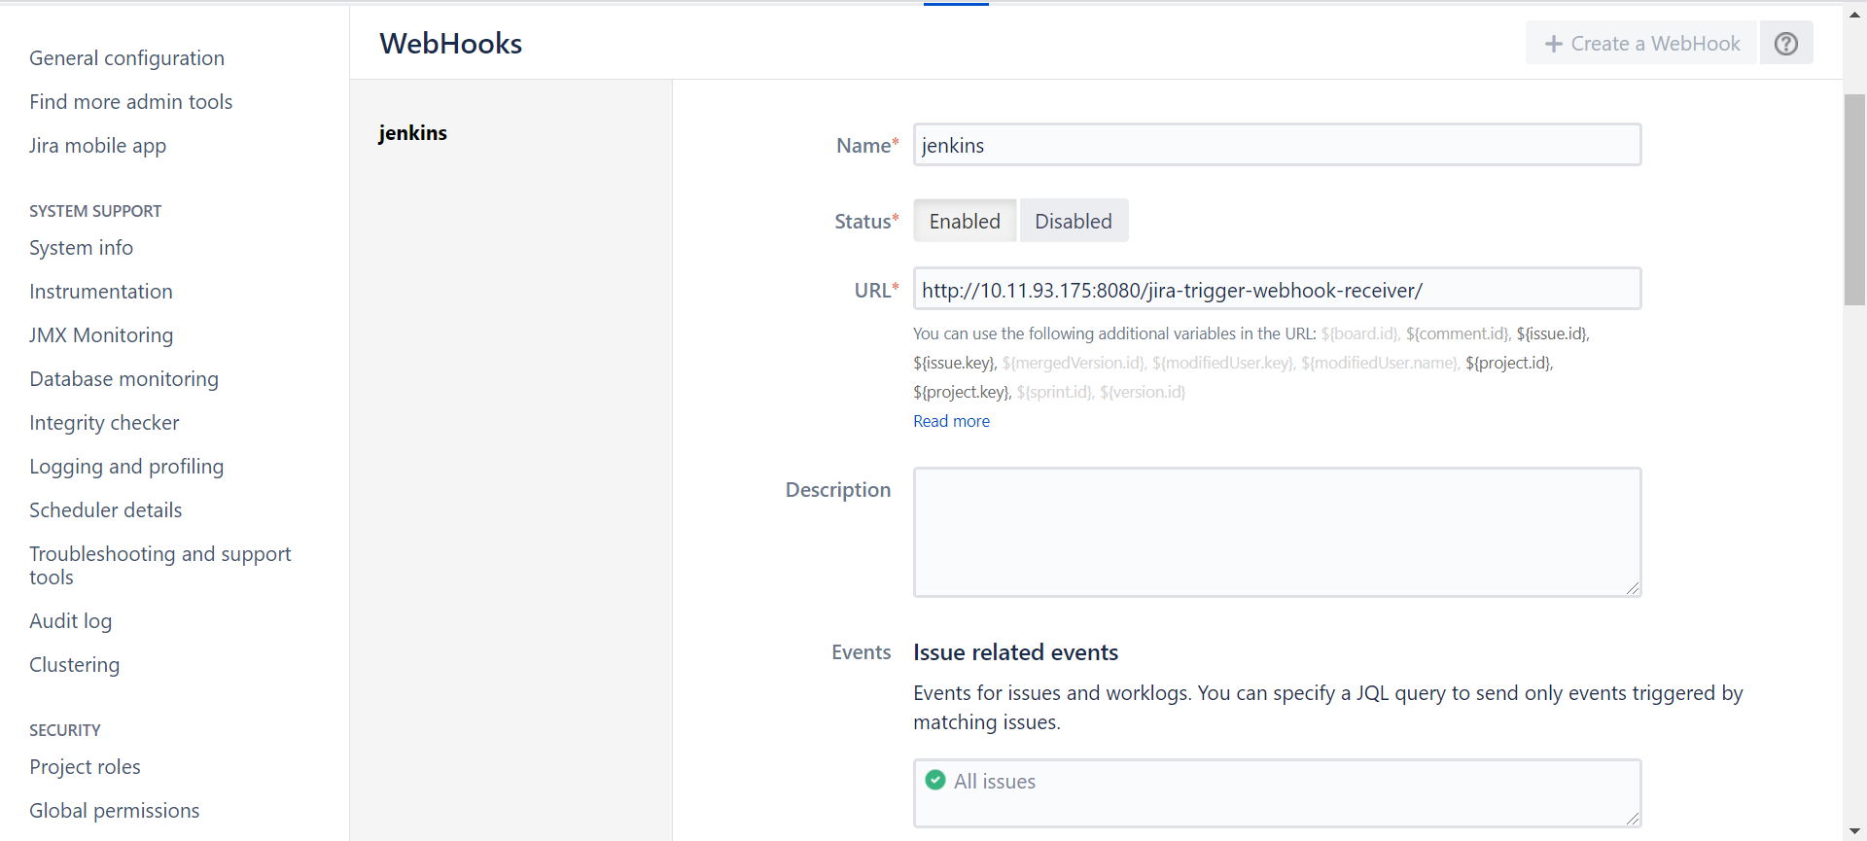

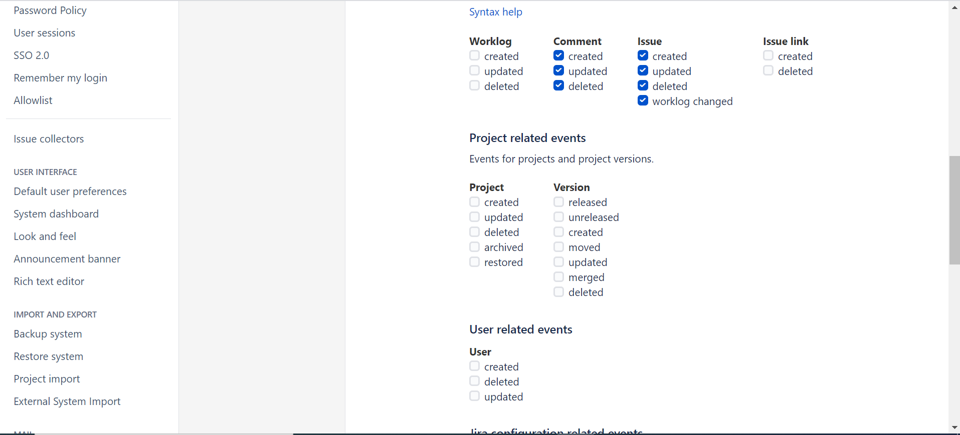

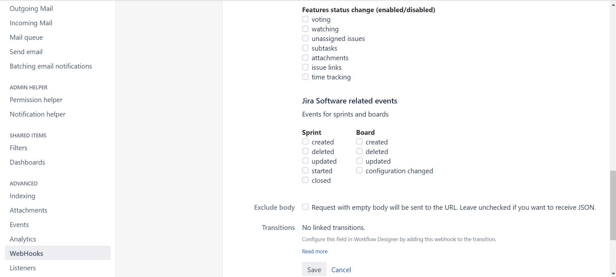

* After parameters save the file

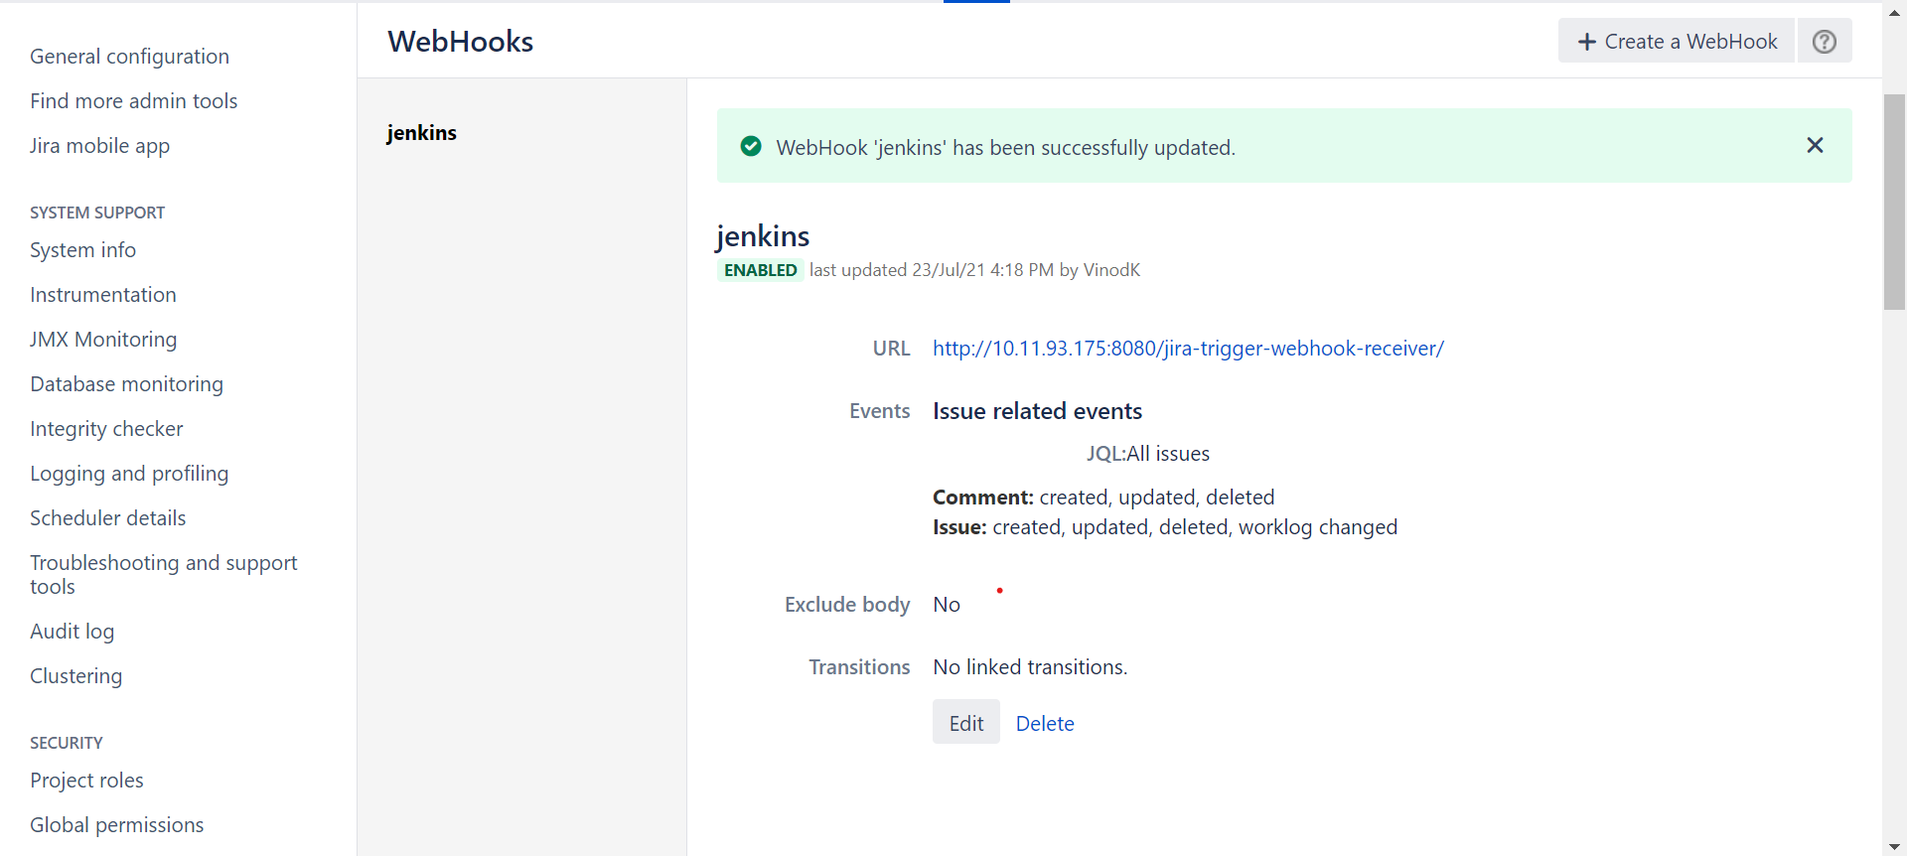

* After webhook setup create a project in Jira

## 4 . Create a project in JIRA

* Choose project option
* Create a project (sonarqube)
* Create issue inside project

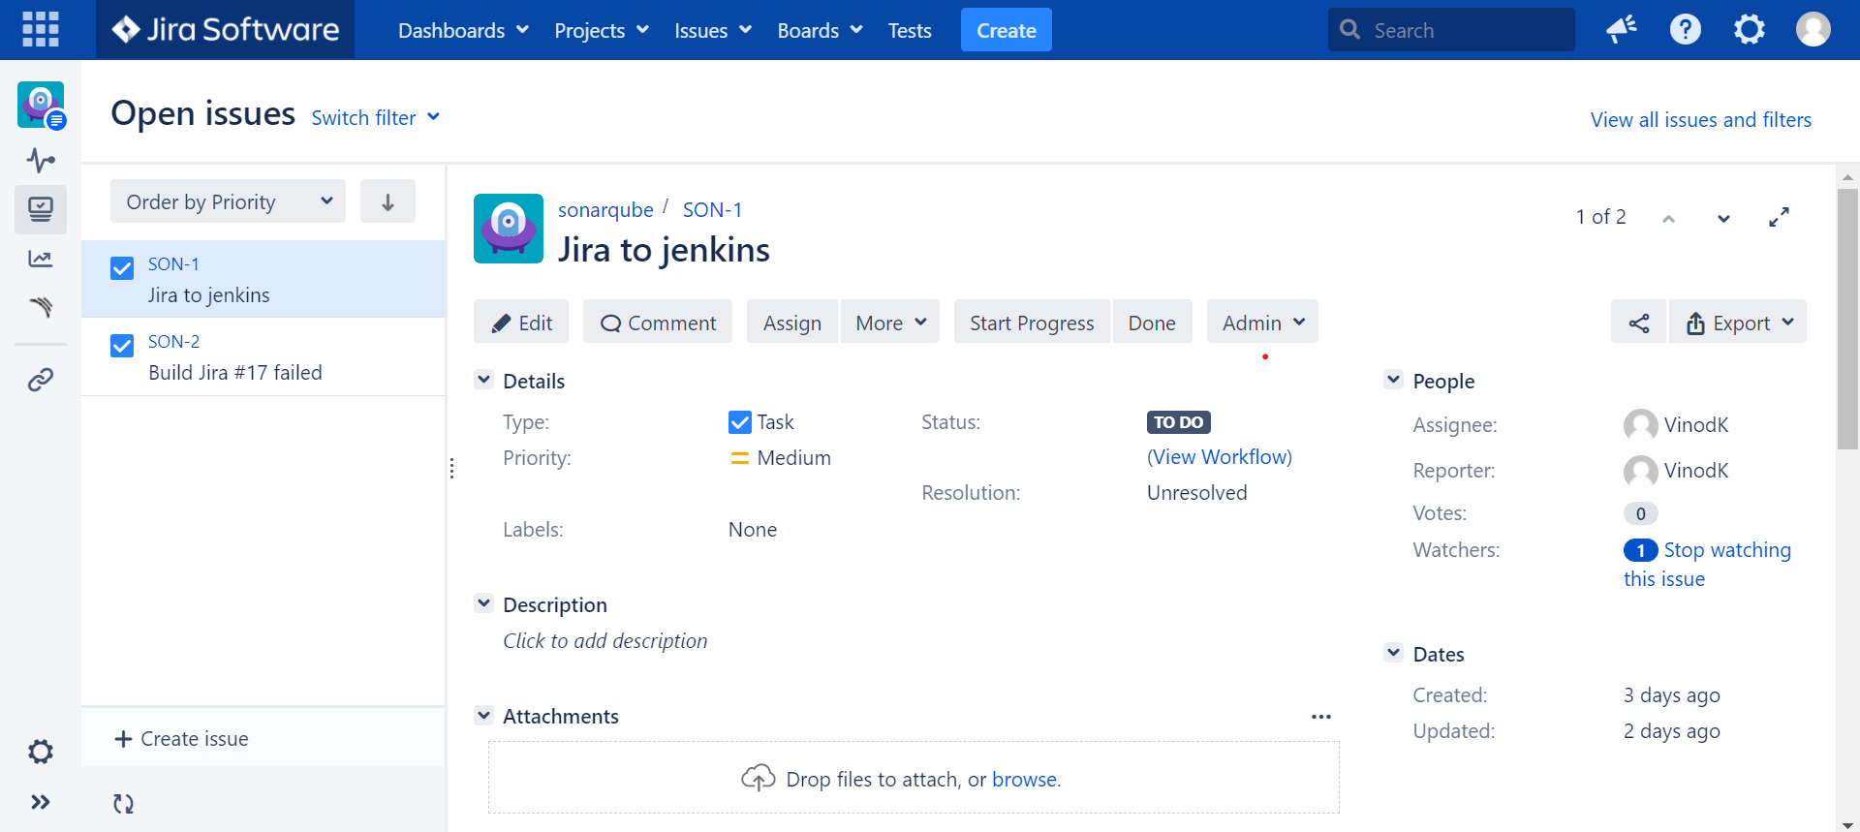

* Changing status TODO to START PROGRESS automatically triggering the Jenkins build(SON-1)
* If Jenkins build goes fails

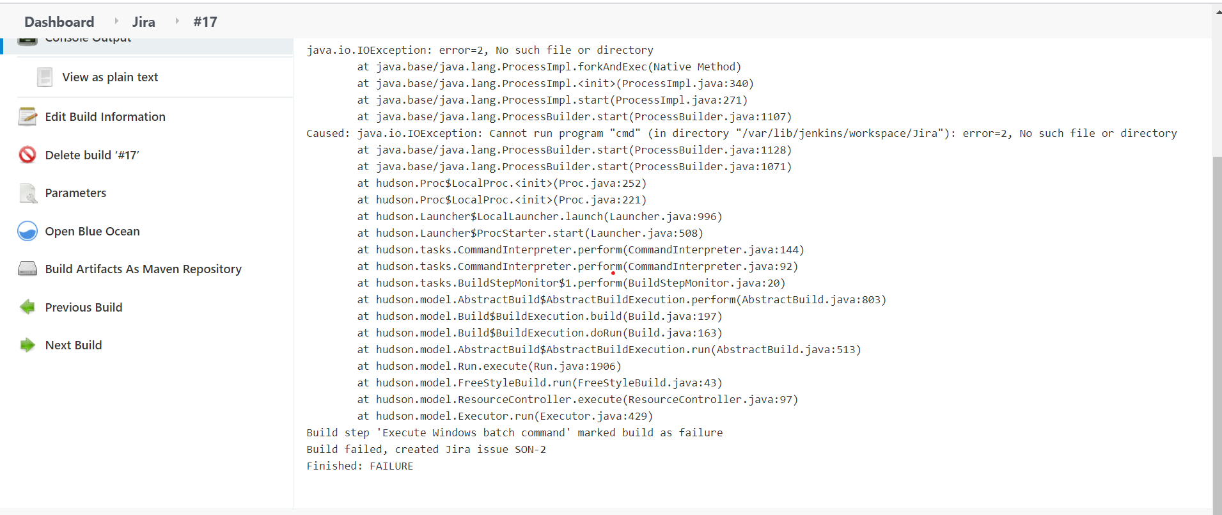

* Automatically ticket generated in Jira
* In jira Jenkins failed (son-2) generated ticket

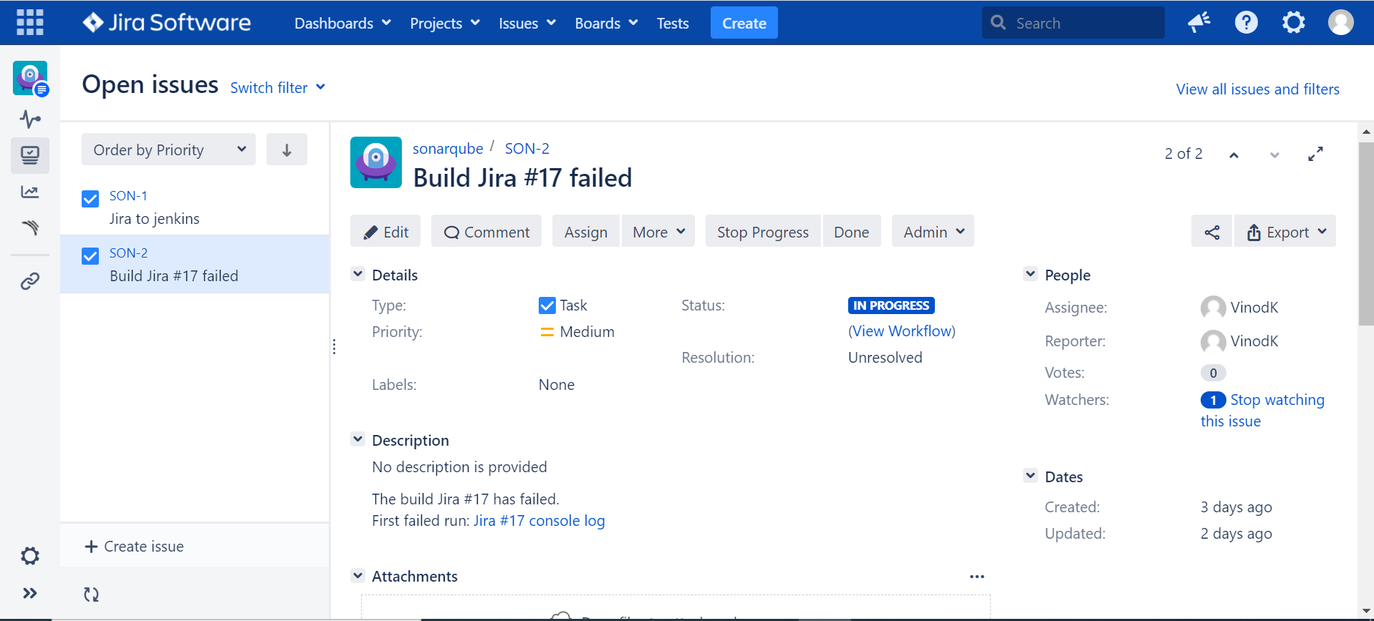

* Again build fails comments will updated data build no and console log

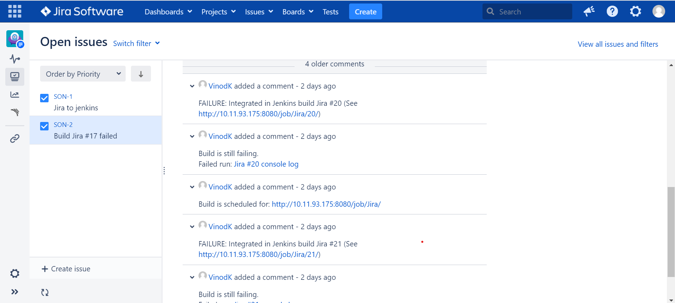

* Redirect to Jenkins page console output

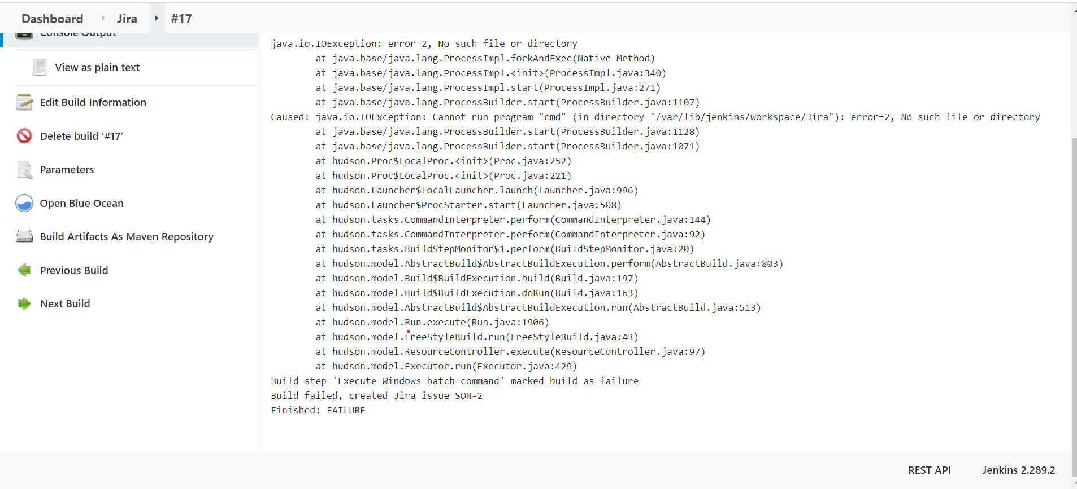

* Please refer console output in Jenkins build.

Note: Jenkins build goes fails then generated ticket in jira.